LINX Connection IWD

To be able to use Enea LINX for inter-processor message based communication an interface needs to be defined for connection establishment, supervision and message passing. This IWD specifies such an interface and is valid for the HPI, sRIO direct IO and ATM Connection Managers.

Contents

1 Introduction 3
1.1 Revision History 3
1.2 Purpose 4
1.3 Assumptions 4
1.4 Readers Guideline 4
2 Interface Overview 5
2.1 L2 Interface support 5
3 States 6
4 LINX Connection Procedures 7
4.1 Procedure Connect 7
4.2 Procedure Supervise 9
5 Message Contents 11
5.1 User Data 12
5.2 Control Data 13
6 Information Element Coding 13
6.1 Common Information Elements 13
7 Timers 15
8 Terminology 17
9 References 17

Introduction

Revision History
Revision | Date | Author | Description
A | 2007-09-14 | QRACEKL | Approved according to IR 2/1776-92/FCP103 6505.
B | 2008-07-30 | QJOEERI | Approved according to IR 87/1776-92/FCP103 6505.  New since revA:  - CR WRNad91444
C | 2009-09-10 | QJOEERI | Approved according to IR 32/1776-10/FCP1018490.  New since revB:  - CR WRNae29455
D | 2010-03-15 | QMAGSKY | Approved according to IR 73/1776-10/FCP 101 8490 Uen  New since rev C (by qmalpih):  Updated due to solution of TR WRNae72165, WRNae55808, WRNae66553
E | 2010-11-08 | QMAGSKY | Approved according to IR 71/1776-52/FCP1016061 Uen  New since rev D(by qtommyf):  Updated due to solution of  TR: WRNae92620 and subsequent CR:WRNae94064 (HPI & ATM CM, different timeouts)
F | 2011-06-09 | QMAGSKY | Approved according to IR 116/1776-10/FCP101 8490 Uen  New since rev E (by qmagsky):  - WRNae94839, Implement, deliver and document improvement from Verizon Task Force  - WRNae95674, Doc errors in FD BPP, LINX Conn IWD
PG1 | 2012-07-05 | EHANBJU | Document converted to MS-WORD format. No new functionality added. Renumbered table 6 & 7 due to a missing table.

Purpose
The purpose for this IWD is to support Enea LINX for inter-processor communication.
The messages defined in the IWD are suited for media where message based communication is used. It is used for HPI, sRIO direct IO and ATM medias.
For some media messages is not an optimal solution. The format of the messages defined in chapter 5 can then not be used. In that case it is up to the Connection Managers at the opposite sides to agree on how the information elements, which all are required, are exchanged.
The supervision part of this IWD is optional. Whether it is used or not has to be negotiated between the Connection Managers at the opposite sides. It is however mandatory to respond to a supervision message if received.

Assumptions
There is no revision negotiation over this interface.

Readers Guideline
This IWD is valid for inter-processor communication where a connection between the LINX Connection Managers needs to be established and supervised.

Interface Overview
The LINX Connection interface provides procedures to setup and supervise connections between Connection Managers. Figure 1 shows an overview of how the inter-processor message passing communication works.
RLNH
Side A
RLNH interface
RLNH
Side B
HW driver
HW driver
Application
Application
Connection Manager
Connection Manager
Connection
physical
communication
Message
communication
interface
Figure 1 Interface overview for LINX communication.

L2 Interface support
The supporting L2 entity which carries the Connection interface messages described in this document will secure the integrity of data, i.e. that the contents of a received message is correct. In the case of a detected fault in a message, the layer 2 entity will not present the message and it will not engage any re-transmission i.e. the message is considered as lost.

States
DISCONNECTED
CONNECTING_2
CONNECTED
CONNECTING_1
dc_connect();TMO/
CONNECT
CONNECT/
CONNECT_ACK
ACK/
CONNECT_ACK/
ACK, uc_connected()
PING;PONG;UDATA;dc_transmit()/
PONG;-;uc_deliver();UDATA
*/RESET
*/RESET
dc_finalize()/-
dc_initialize()
Commands in capital letters denote Linx Connection messages Commands in lower case letters denote RNLH interface. Error – Unspecified unrecoverable event
d
c_disconnect();
*/
uc_disconnected;()
***RESET
, uc_disconnected()
uc_connected()
RESET is not sent as
response to RESET
**
CONNEC
T/CONNECT_ACK
**CONNECT/-
** What CONNECT scenario that is chosen depends on value of supa. Smallest supa will enter state CONNECTING_2. This state transition is only valid for ATM and only on the DP side.
*** RESET is not sent
for sRIO CM.
*TMO (Time out) or other message/Error
Figure 2 LINX Connection state machine
The LINX Connection state machine is shown in Figure 2. The state transitions are further described in chapter 4. The timers causing the time out events in the figure are described in chapter 7. The interface between RLNH and the Connection Manager is described in [2]. It is only added as an example and is not a part of this IWD.

LINX Connection Procedures
This section specifies the procedures for this interface. The figures show only the successful outcomes. The unsuccessful are described in the text. Timer values are specified in chapter 7.

Procedure Connect

Purpose and sequence
The purpose of this procedure is to bring the Connection Managers on side A and side B to Connected state.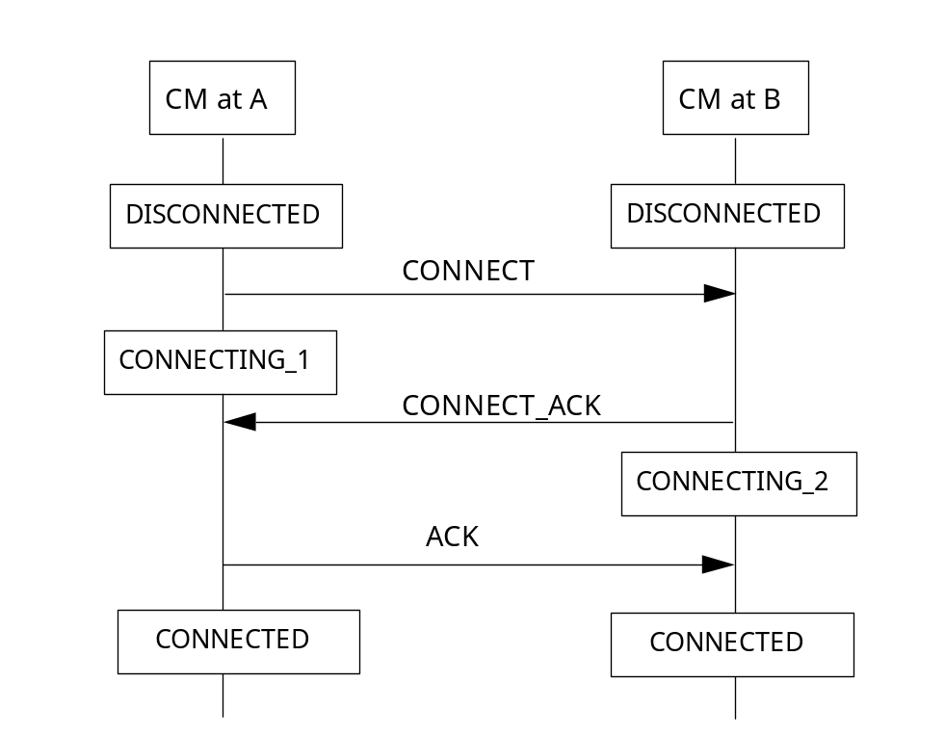
Figure 3 Sequence for normal procedure Connect

There exists a special case where both Connection Managers send a CONNECT message at the same time and enters the state CONNECTING_1. The scenario is illustrated in Figure 4.
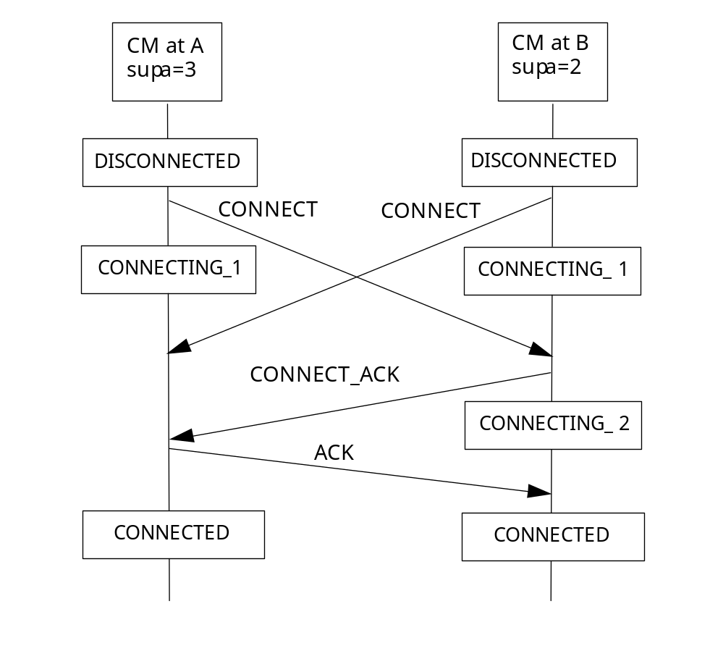
Figure 4 Sequence when both CMs initiate the procedure at the same time

Prerequisite
The Connection Manager at the initiating side, side A, has received a dc_connect() call, or corresponding, from RLNH.

Initiation
The Connection Manager at A sends a CONNECT message and starts a CONNECT_ACK timer. State CONNECTING_1 is entered.
The Connection Manager at the B side responds with a CONNECT_ACK, starts an ACK timer and enters state CONNECTING_2.

Termination

Successful Outcome
The successful outcome can be split into two cases. The first scenario is that the Connection Manager at the A side receives a CONNECT_ACK message, sends an ACK to the B side and enters state CONNECTED.
The Connection Manager at the B side receives an ACK message and enters state CONNECTED.
The other scenario includes that the Connection Manager at the A side and the B side receives a CONNECT message at the same time. In this case would both Connection Managers have entered state CONNECTED-_1 and consequently must one of the them surrender. This is arranged by letting the Connection Manager with the smallest supa (CM B in Figure 4) enter state CONNECTING_2 if a CONNECT is received and also send a CONNECT_ACK message to the A side.
Same as previous scenario, the Connection Manager at the B side receives an ACK message and enters state CONNECTED.
At this stage user data can be transmitted in a User Data message.
A PING timer is started for the supervision of the connection.

Unsuccessful Outcome
If no response is received on the A or B side before any of the timers expires, or if an unexpected message is received, the procedure is aborted and the Connection Manager that detected the fault shall enter state DISCONNECTED. A CONNECT timer is started. When the timer expires the Connect procedure is performed.

Procedure Supervise

Purpose and sequence
The purpose of this procedure is to supervise the LINX Connection in order to detect a lost connection.

Prerequisite
The Connect procedure has successfully been performed.

Initiation
The PING timer expires on either side of the connection. The Connection Manager on the side the timer expires sends a PING to the other side and starts a PONG timer.

Termination

Successful Outcome
The Connection Manager that sent the PING receives a PONG from the other side.

Unsuccessful Outcome
The PONG timer expires. State DISCONNECTED is entered. A CONNECT timer is started. When the timer expires the Connect procedure is performed.

Message Contents
For each message in this section there is a table listing the information elements permitted to be in that message and their order of appearance in the transmitted message.
The following abbreviations and concepts are used in the descriptions of messages.
“M” “Mandatory” indicates that the information element is mandatory in the actual message.
“O” “Optional” indicates that the information element is optional in the actual message.
“F” “Fixed” indicates that the information element is of fix length.
“V” “Variable” indicates that the information element is of variable length.
A->B The message or element can be sent in the direction from CM at A to CM at B.
B->A The message or element can be sent in the direction from CM at B to CM at A.
Both The message or element can be sent in both directions.
Local A message has local significance when it is relevant only on the originating or terminating side of the call.
Global A message has global significance when it is relevant both on the originating and terminating side of the call.

User Data
This message carries User Data. Observe that information elements may be un-aligned.

Message Type: User Data
Significance: Global
Information Element | Reference | Direction | Class  M/O | Info  F/V | Length  Octet | Remarks
messageId | U32 | Both | M | F | 4 | Message identifier, see Table 3.
srcAddr | U32 | Both | M | F | 4 | User data sender. See [1] and [2] for its application.
dstAddr | U32 | Both | M | F | 4 | User data destination. See [1] and [2] for its application.
Data | Array of U8 | Both | M | V | total message length - 12 | User data. Also see Table 4 for length.
Table 1 User Data message.

Control Data
This message controls the LINX Connection state machine.
Message Type: Control Data
Significance: Global
Information Element | Reference | Direction | Class  M/O | Info  F/V | Length  Octet | Remarks
messageId | U32 | Both | M | F | 4 | Message identifier, see Table 3.
Table 2 Control Data message.

Information Element Coding
Each bit position is marked as 1 to 8. Bit 1 is the least significant bit. Bit 8 is the most significant bit. The bit transmission sequence in each octet is in the order of Bit 8, Bit 7… until …Bit 1. Accordingly, octets in each message are transmitted in the sequence of octet 1, octet 2…
When a field extends over more than one octet, the order of bit values progressively decreases as the octet number increases. The least significant bit of the field is represented by the lowest numbered bit of the highest numbered octet of the field (Note: This way of encoding is called "Big-Endian").

Common Information Elements

Message Identifier Information Element
The purpose with the Message Identity information element is to distinguish between the different LINX Connection messages so that the specific message can be interpreted. The Message Identity length is 4 octets.
The Message Identity shall be located at the end (i.e. be the last octets) in all messages.
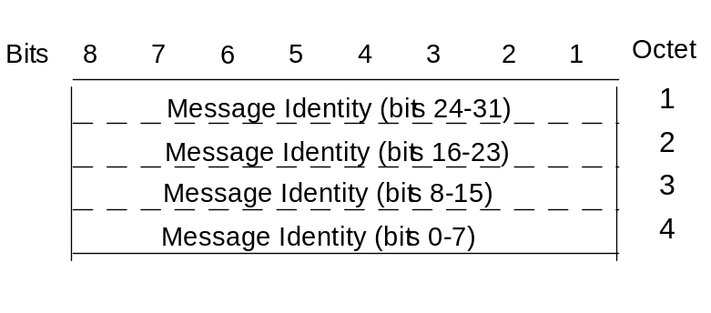
Figure 5 Message Identity layout.

Message identifiers
messageId | Value
UDATA | 0x00000000
CONNECT | 0x00000001
CONNECT_ACK | 0x00000002
ACK | 0x00000003
RESET | 0x00000004
PING* | 0x00000005
PONG* ** | 0x00000006
Table 3 Message identifier values. *Optional. **Mandatory to respond to a received ping!

U8
U8 is a data type that represents the unsigned character with the size of one octet.

U32
U32 is a data type that represents the unsigned long with the size of four octets.

Array
An array can be of variable or fixed length. The space required is reserved as a contiguous number of unsigned characters.
Defined Array length constants are:
Constant Name | Constant Value | Remark
MAX_MESSAGE_LENGTH | 2048 | Maximum length of a LINX Connection message. 2036 (2048 - 12 bytes for control data) bytes can be used for user data in a User Data message. Source: [3]
Table 4 Array length definitions.

Timers
The tables below specify the time constants used with the LINX Connection interface. There are two different kinds of timers. The values are given in milliseconds. There are two tables: one for the HPI/sRIO CM and one for the ATM CM.
- Maximum time to wait for the response to a commands.
- Interval time between sending consecutive messages

Constant Name | Constant Value | Remark
CONN_ACK_MAXTIME | 200 | A CONNECT_ACK timer.  Valid at the A side.  Maximum time between sending a CONNECT and receiving a CONNECT_ACK
ACK_MAXTIME | 200 | An ACK timer.  Valid at the B side.  Maximum time between sending a CONNECT_ACK and receiving an ACK.
PONG_MAXTIME | 1000 | A PONG timer.  Valid at both side A and B.  Maximum time between sending a PING and receiving a PONG.
PING_INTERVAL | 2000 | A PING timer.  Valid at both side A and B.  Time interval between sending two PING.
CONNECT_INTERVAL | 100 + CONN_ACK_MAXTIME + small random time | A CONNECT timer.  Valid at both side A and B.  Time interval between two CONNECT attempts.  Note that the first CONNECT attempt should be made after the small random time only.
Table 5 Timer constants for the HPI and sRIO CMs (in ms).

Constant Name | Constant Value | Remark
CONN_ACK_MAXTIME | 40 | A CONNECT_ACK timer.  Valid at the A side.  Maximum time between sending a CONNECT and receiving a CONNECT_ACK
ACK_MAXTIME | 40 | An ACK timer.  Valid at the B side.  Maximum time between sending a CONNECT_ACK and receiving an ACK.
PONG_MAXTIME | 1000 | A PONG timer.  Valid at both side A and B.  Maximum time between sending a PING and receiving a PONG.
PING_INTERVAL | 2000 | A PING timer.  Valid at both side A and B.  Time interval between sending two PING.
CONNECT_INTERVAL | 40 + CONN_ACK_MAXTIME + small random time | A CONNECT timer.  Valid at both side A and B.  Time interval between two CONNECT attempts.  Note that the first CONNECT attempt should be made after the small random time only.
Table 6 Timer constants for the ATM CM (in ms).

Terminology
ATM Asynchronous Transfer Mode
CM Connection Manager
HPI Host Port Interface
RLNH Rapid LiNk Handler - Link handler component of Enea LINX

References
- LINX Protocol at Linx project homepage on Sourceforge.
http://linx.sourceforge.net/linxdoc/doc/index.html
- rlnh_link.h, header file describing the interface between RLNH and the connection interface
- BCP Characteristics Requirement Specification, 1/1056-CRH 109 064/1

